LAB 4: Inserting Initial Data into the Database
Aim
To insert initial data into the SQL Server database using Entity Framework Core.

Objective
- Create category and product objects.
- Insert records using AddRangeAsync().
- Save data using SaveChangesAsync().
- Verify the inserted data in SQL Server.

Tools Required
- Visual Studio Code
- .NET SDK
- SQL Server Express
- SQL Server Management Studio (SSMS)
- Entity Framework Core

Procedure
Step 1: Create Category and Product Objects
Created Category and Product objects with the required values in Program.cs.
Step 2: Insert Data
Inserted the records into the database using AddRangeAsync() and saved the changes using SaveChangesAsync().
await context.Categories.AddRangeAsync(electronics, groceries);
await context.Products.AddRangeAsync(product1, product2);
await context.SaveChangesAsync();
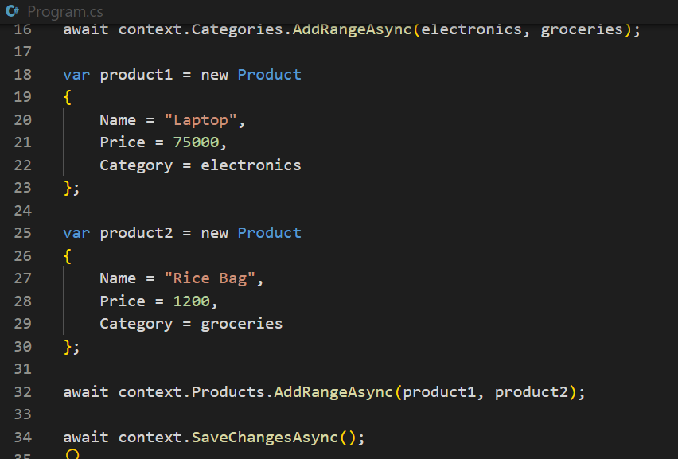
Step 3: Run the Application
Executed the application using the following command:
dotnet run
The application inserted the records into the SQL Server database successfully.

Step 4: Verify the Data
Opened SQL Server Management Studio (SSMS) and verified that the records were successfully inserted into the Categories and Products tables.
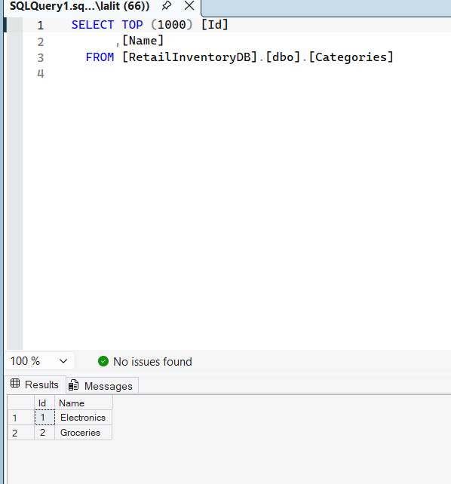
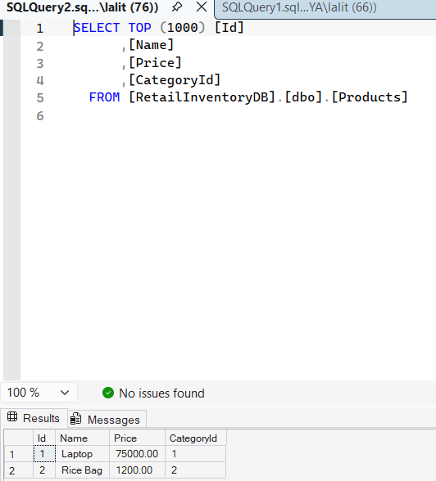

Result
The initial category and product records were successfully inserted into the SQL Server database using Entity Framework Core. The inserted data was verified successfully in SQL Server Management Studio (SSMS).

